Scrum Board

**To do: Go through the activity to the end**

A scrum board allows the issues of one or more projects to be displayed in columns that are not started, in progress and done.

✔ [What is Board?](https://lms.clarusway.com/mod/lesson/view.php?id=581)  
✔ [Let's Practice](https://lms.clarusway.com/mod/lesson/view.php?id=581&pageid=2885)  
✔ [Creating Scrum Board](https://lms.clarusway.com/mod/lesson/view.php?id=581&pageid=2937)  
✔ [Step-1 (Click "+ Create board")](https://lms.clarusway.com/mod/lesson/view.php?id=581&pageid=719)  
✔ [Step-2 (Click "Create a Scrum board")](https://lms.clarusway.com/mod/lesson/view.php?id=581&pageid=720)  
✔ [Step-3 (Options for Creating Board)](https://lms.clarusway.com/mod/lesson/view.php?id=581&pageid=721)  
✔ [Step-4 (Dialogue Box)](https://lms.clarusway.com/mod/lesson/view.php?id=581&pageid=722)  
✔ [Let's Practice](https://lms.clarusway.com/mod/lesson/view.php?id=581&pageid=2887)  
✔ [Using Scrum Backlog](https://lms.clarusway.com/mod/lesson/view.php?id=581&pageid=723)  
✔ [Let's Practice](https://lms.clarusway.com/mod/lesson/view.php?id=581&pageid=2889)  
✔ [Creating Versions](https://lms.clarusway.com/mod/lesson/view.php?id=581&pageid=735)  
✔ [Step-1 (Click on "VERSIONS")](https://lms.clarusway.com/mod/lesson/view.php?id=581&pageid=736)  
✔ [Step-2 (Click on "Create Version")](https://lms.clarusway.com/mod/lesson/view.php?id=581&pageid=737)  
✔ [Step-3 (Dialogue Box)](https://lms.clarusway.com/mod/lesson/view.php?id=581&pageid=738)  
✔ [Let's Practice](https://lms.clarusway.com/mod/lesson/view.php?id=581&pageid=2940)

What is Board?

A **board**allows you viewing issues from one or more projects and gives you simplicity in managing, viewing, and reporting ongoing work. There are three types of boards in the Jira Software:

| **Type of Board** | **For Which Teams?** |
| --- | --- |
| Scrum board | Teams that plan their work in sprints. |
| Kanban board | Teams that focus on managing and constraining their work-in-progress. |
| Next-gen board | Teams who are new to agile. |

**💡Tips:**

* You need to be the administrator in the project to manage the board configuration.

Board you viewing issues from one or more projects and gives you simplicity in managing, viewing, and reporting ongoing work.

### Creating Scrum Board

In order to start using Jira Software for Scrum, we need to create a Scrum board for our project. As we recall from previous lesson, we created a project using the Scrum project template when creating our site, so there is an automatically generated Scrum board for us along with the project.

If you need to create a board in your current project, this process can be performed from the project page. Now let's see how you can create a board step by step.

A scrum board allows the issues of one or more projects to be displayed in columns that are not started, in progress and done.

Step-1 (Click "+ Create board")

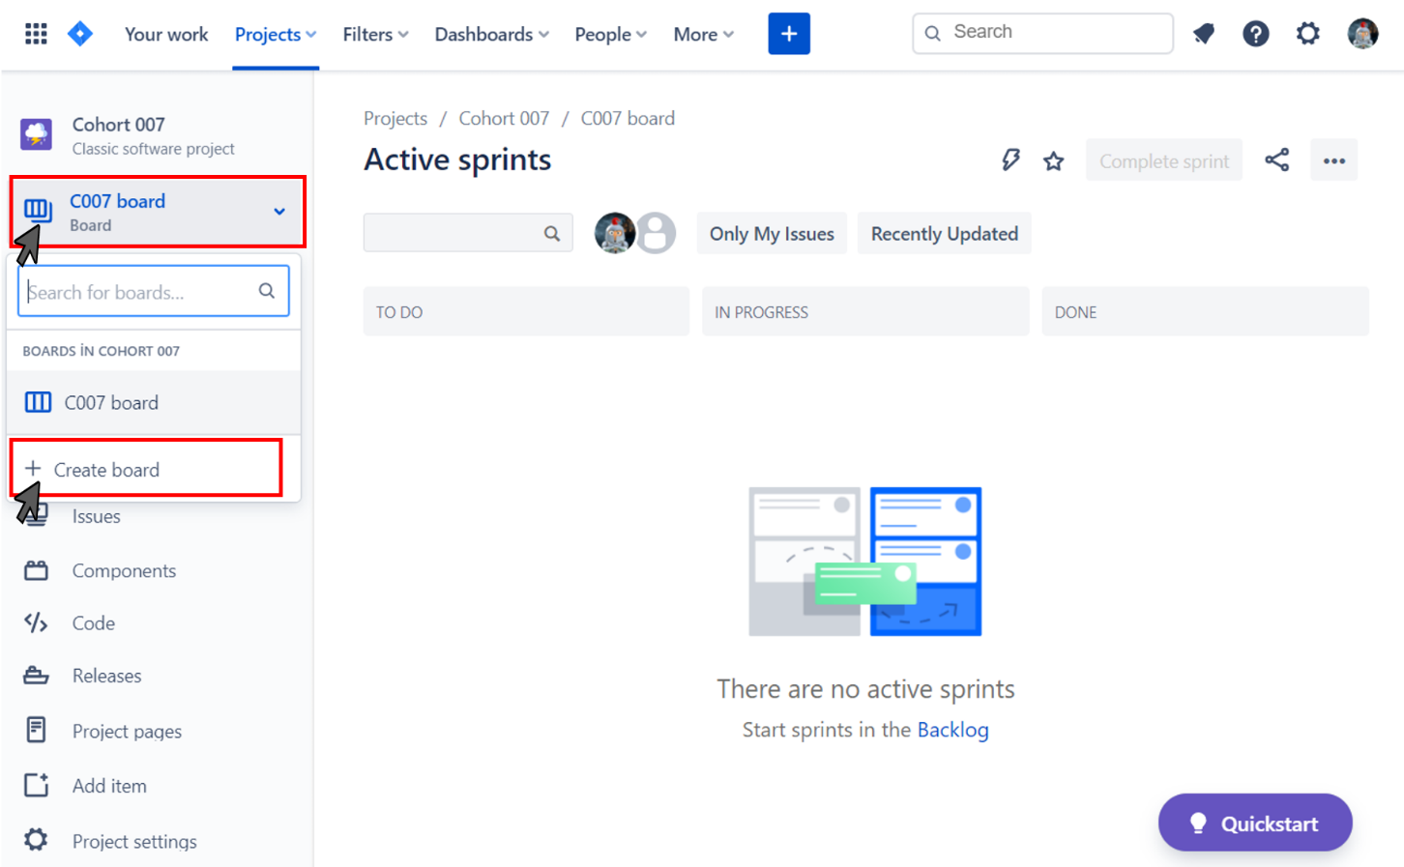

Go to the "Board" button from the menu on the left on your project page. Then, click the "+ Create board" button that will appear on the screen.

### Step-2 (Click "Create a Scrum board")

### 

You will see Scrum and Kanban options. Select the Scrum board by clicking "Create a Scrum board".

### Step-3 (Options for Creating Board)

Choose how you want your board to be created from the following three options, then click on the "Next" button.

a. Board created with new Software project: A new board based on a new software project.

b. Board from an existing project: Boards can contain one or more projects.

c. Board from an existing Saved Filter: An advanced option using a JQL filter.

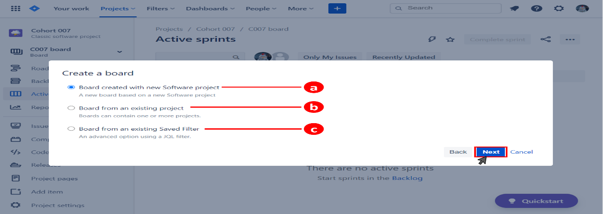

* JQL stands for Jira Query Language and is the most powerful and flexible way to search for your issues in Jira.

### Step-4 (Dialogue Box)

You will create a project to finalize creating your board. On the "New project with board" dialogue, fill in the required information below and click the "Create board" button.

a. Project name

b. Project key

c. Project lead

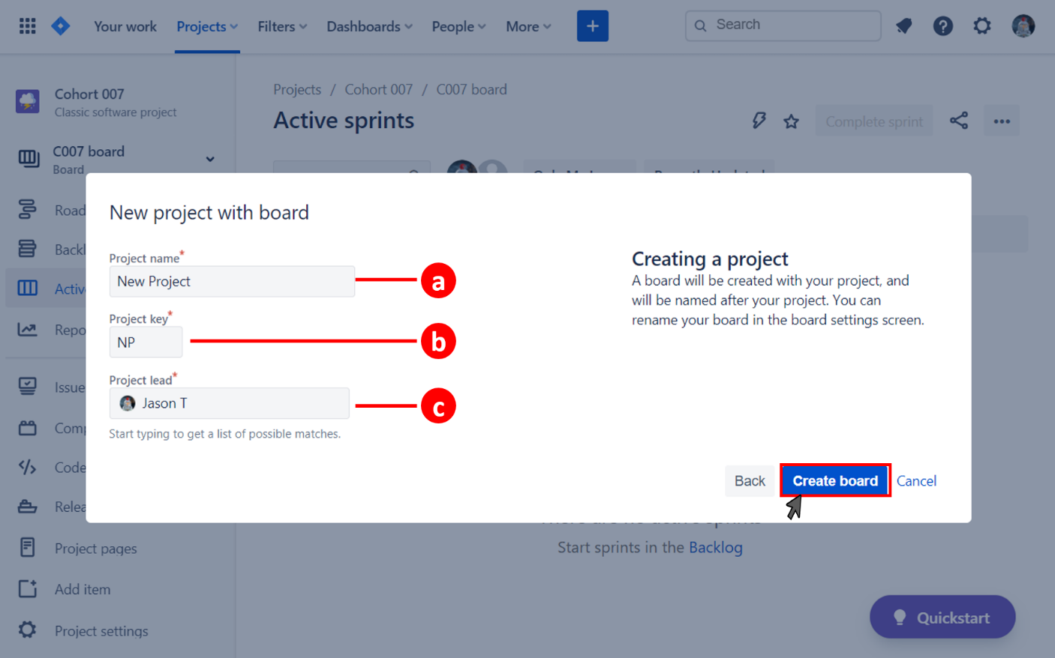

Formun Üstü

Formun Altı

**💡Tips:**

* A project key is a unique code for your project.
* Jira Software will automatically generate a short project key in accordance with your project name.
* However, if you want to specify this auto-generated key yourself, you can change it.

**Q**: What is project key in Jira Software?  
**A**: A project key is a unique code for your project. Jira Software will automatically generate a short project key in accordance with your project name.

### Using Scrum Backlog

So far we have learned to set up a project. We have chosen Scrum as a project template and it's time to prepare the backlog issues our team will work with.

A backlog is a list of issues that can be created for your project. You can create issues and sprints in the backlog. Then, you can add issues to a sprint so that your team can work on it. These issues are not detailed features in your backlog.

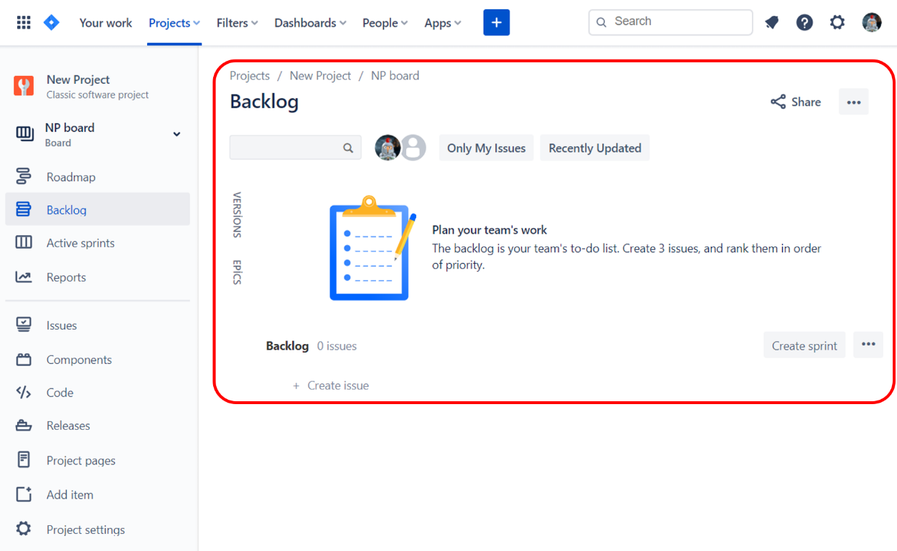

You can do the following things in the Scrum backlog:

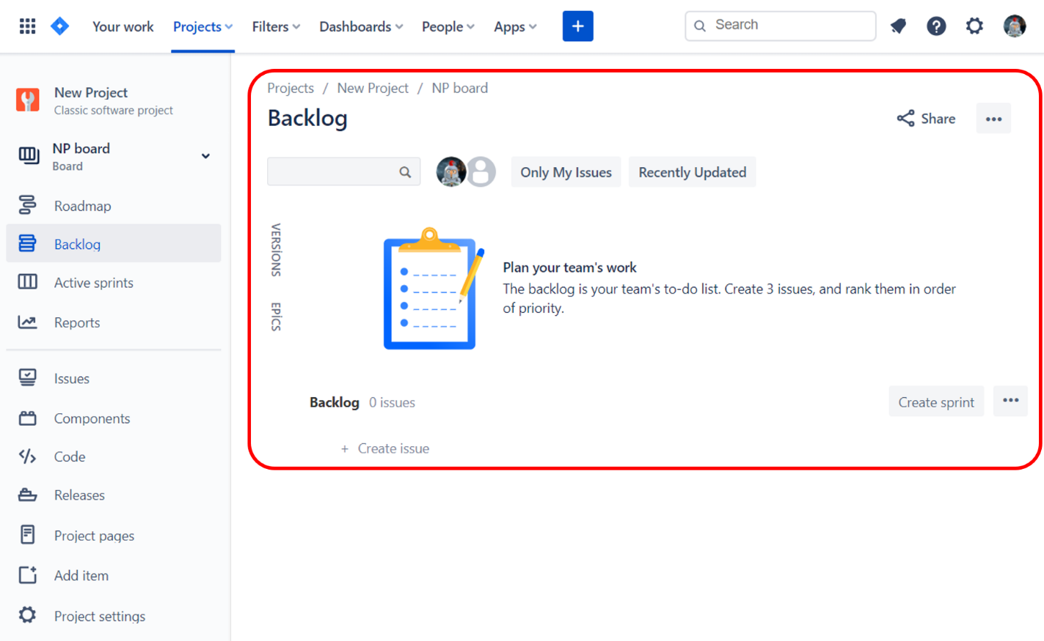

**Q**: Explain briefly what is backlog.  
**A**: A backlog is a list of issues that can be created for your project. You can create issues and sprints in the backlog. Then, you can add issues to a sprint so that your team can work on it.

Creating Versions

In Jira Software, the versions represent the points of a project over time. With versioning, you can plan the order in which new features and fixes for the product will be released to your customers.

Follow these steps to create a new version from your Scrum board.

**Q**: Explain briefly what is version.  
**A**: The versions represent the points of a project over time. With versioning, you can plan the order in which new features and fixes for the product will be released to your customers.

### Step-1 (Click "VERSIONS")

Click on "VERSIONS" from the left-hand panel on the backlog screen.

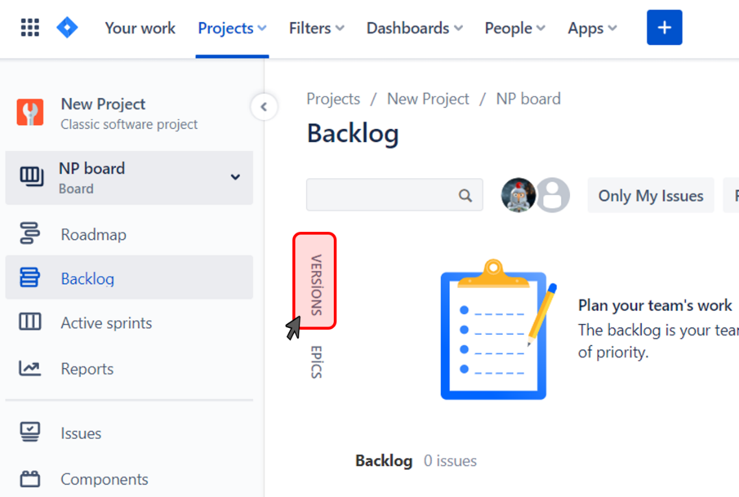

Step-2 (Click "Create Version")

Click on the "Create Version" link in the expanded Versions panel. This will direct you to the "Create version" dialogue box.

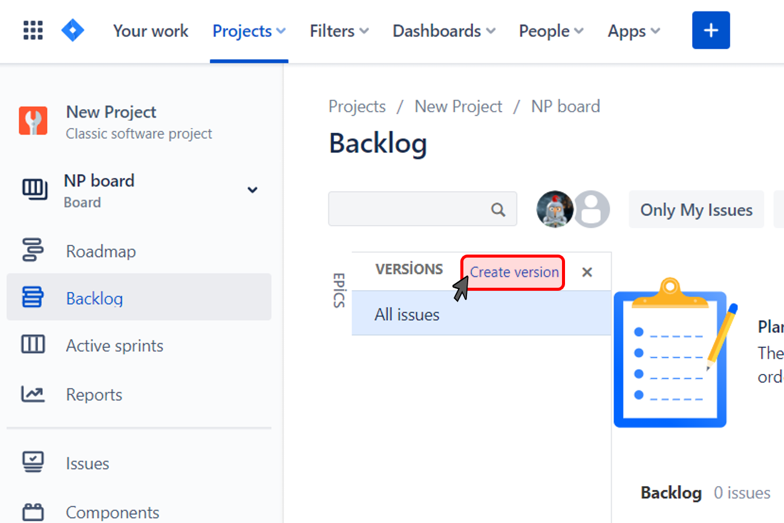

### Step-3 (Dialogue Box)

To create a version, you must fill in the fields in the dialogue box as shown in the following picture. Once you created a version, you can see it in the Versions Panel.

a. Select the Project

b. Provide a Name for the version

c. Provide a Description

d. Edit Start Date

e. Edit Release Date

f. Click on the Create button

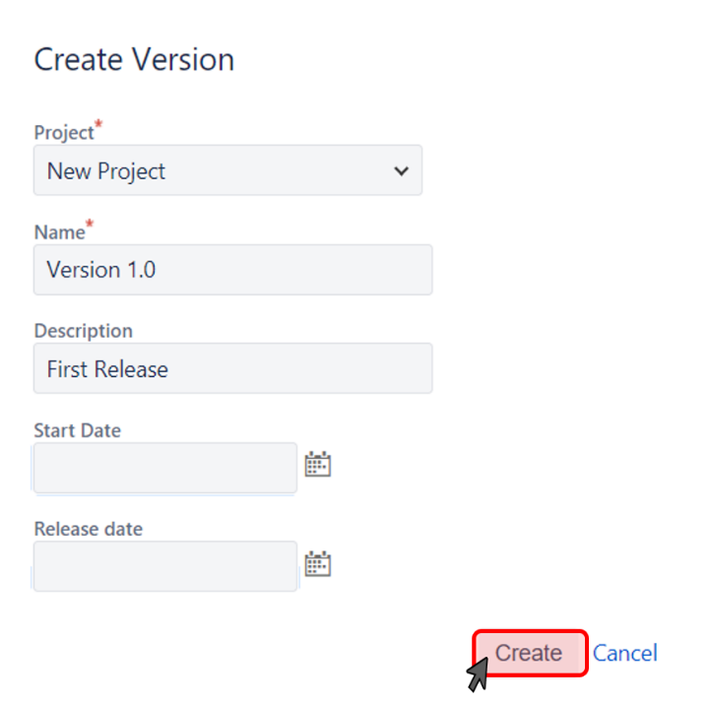

Typically, version names are generated from numbers, for example 1.1 or 2.1.2. It may also be an option to use an internal code name. You can create as many versions as necessary. For example, you can create several versions at a time, or you can only have one version for now.

### What is an Issue?

An issue in Jira is a task. It could be a small task like changing the bulb in reception. A large task would be replacing all the bulbs in the building. It all depends on your project and how your team breaks down your work. Every issue in Jira is unique and belongs to one project.

During your sprint planning, you can create issues that you plan to work on and add them to the backlog.

Depending on how your team uses Jira, an issue can represent a

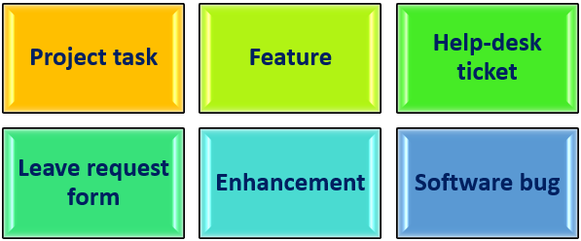

**Q**: What is an issue in JIRA Software?  
**A**: In Jira, teams use issues to track individual pieces of work that must be completed. During the sprint planning, users can create issues that they plan to work on and add them to the backlog.

**Q**: What is referred as issues in Jira?  
**A**: Depending on how a team uses Jira, an issue can represent followings: Project task, Feature, Help-desk ticket, Leave request form, Enhancement, Software bug

### Issue Types

In your projects, there are different types of units of work. Issue types in Jira can be defined in short sentences as follows:

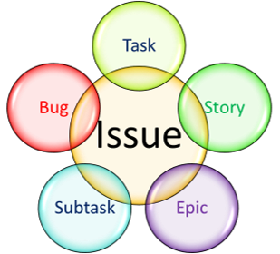

* **Epic:**An epic is a set of jobs that can be divided into manageable user stories.
* **Story:** A story is a short requirement written from an end-user perspective.
* **Task:** A task represents the job that needs to be done.
* **Subtask:** A subtask can be considered as a smaller piece of a story.
* **Bug:** A bug impairs expected functionality of the product.

**💡Tips:**

* The hierarchy for units of work in Jira Software is as follows: Project > Epics/Components > Stories > Tasks > Subtasks
* Teams can customize the names of issue types to match their specific project requirements.
* Each issue type can have different fields, screens and workflows.

**Q**: List and briefly describe the issues types in Jira Software.  
**A**: Issue types can be defined in short sentences as follows: A bug is a problem which impairs or prevents the functions of a product. An epic is a big user story that needs to be broken down. A subtask is a piece of work that is required to complete a task. A user story is the smallest unit of work that needs to be done. A task represents work that needs to be done.

Examples for Issue Types

 Here are the icons and some examples for each issue type:

| **Issue Type** | **Icon** | **Examples** |
| --- | --- | --- |
| Epic |  | Full website redesign, Product launch, Quality Assurance Initiative |
| Story |  | As a registered user, I want to send message to sellers, So that I can chat with sellers. |
| Task |  | Redesign a single web page, Create a new logo, Perform usability testing |
| Sub-task |  | Create calendar widget for new web page, Schedule meeting for usability testing, Select colors for new logo |
| Bug |  | Send Mail feature doesn't launch mail client, System crashes when entering addresses with a hashtag, URL directs to nonexistent web page |

### Issue Fields

In the dialog box, you will see a variety of fields. To fill out this box, you need to know the detail of the fields. These fields are:

* Issue type: The issue types you can define in Jira Software are Story, Task, Bug, and Epic. Also, you can add more in the administration section.
* Summary: This field is marked with an asterisk, so you have to write a summary to create an issue.
* Description: This field is where you write a description of your issue.
* Fix versions: This field is used to indicate the future version in which the issue is resolved.
* Labels: This field can be considered as a tag or keywords.
* Environment: This field describes the environment of the issue.
* Attachment: You can attach files to this field from your local drive or cloud storage provider.
* Affects versions: This field describes in which version the bug exists.
* Linked Issues: Using this field, you can link issues in your project.
* Priority: This field describes the priority of the issue. There are five default priorities available in Jira: Highest, High, Medium, Low, and Lowest.
* Assignee: This field represents the user who the issue is assigned to.
* Epic Link: This field is a relational link to identify the parent epic of the issue.
* Sprint: This field is used to add the issue to the sprint that you want to associate with.

### Issue Priorities

The priority of an issue determines how important it is relative to other issues. So you can determine which issues your team should focus on first. The default priorities are listed below, in order from highest to lowest.

| **Priority** | **Icon** | **Description** |
| --- | --- | --- |
| Highest |  | This problem will block progress. |
| High |  | Serious problem that could block progress. |
| Medium |  | Has the potential to affect progress. |
| Low |  | Minor problem or easily worked around. |
| Lowest |  | Trivial problem with little or no impact on progress. |

**💡Tips:**

* Keep in mind that both the priorities and their meanings can be customized by the administrator.

### Issue Workflows

You can define the **life cycle of an issue** by setting up its workflow. Workflows represent the business processes you are working on and allow you to adjust their statuses and transitions within the life cycle of each issue.

The following diagram shows the classic JIRA default workflow:

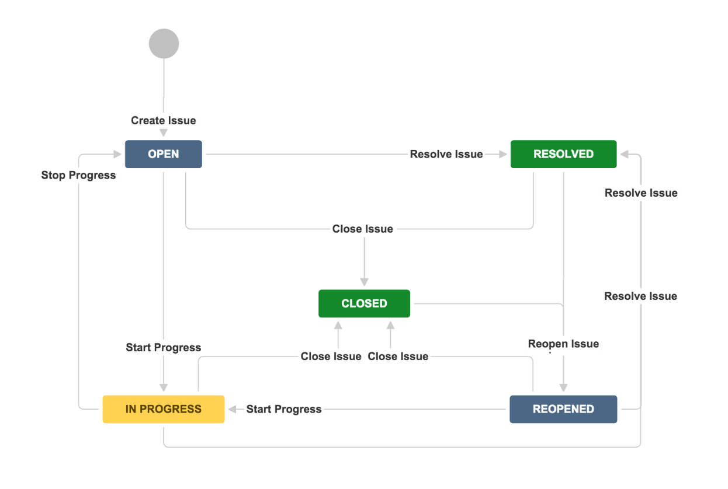

* **Status** represents the stage of an issue at a particular time. An issue can be only in one status at a given time.
* **Transition** is the link between two statuses that allows an issue to move from one status to another. A transition is necessary when an issue moves from one status to another.

**💡Tips:**

* JIRA's system workflow can be customized by your JIRA administrator.

**Q**: What is Jira Workflow?  
**A**: A Jira workflow is a set of statuses and transitions that an issue moves through during its lifecycle, and typically represents a process within your organization. Workflows can be associated with particular projects and, optionally, specific issue types by using a workflow scheme.

### How to Create an Issue

There are two different ways to create issues depending on our preference. We can add issues through the backlog view or by using the global navigation bar on the left menu.

It is very easy to create issues in your backlog:

1. In your project’s sidebar, select Backlog.
2. Scroll to the bottom of your Backlog list and select "+ Create issue".

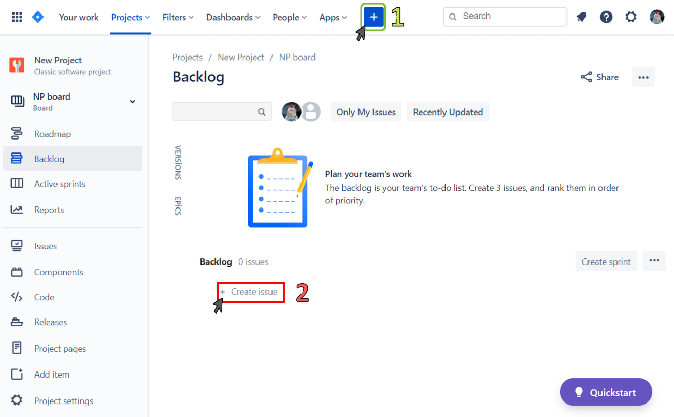

**💡Tips:**

* Only if you are a Jira administrator with the Administer Jira permissions, you can create issue types in classic projects.

Now let's examine how to create a new issue from global navigation bar.

Step-1 (Click on "+")

Click on "+" button from the global navigation bar or press the C key on the keyboard. This will direct you to the "Create issue" dialogue box.

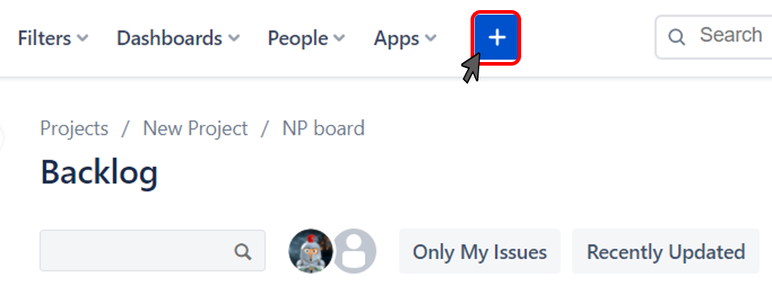

### Step-2 (Dialogue Box)

To create an issue, you must fill in the fields with the asterisk in the dialogue box.

a. Select the Project*,

b. Select the Issue Type*,

c. Provide a Summary*,

d. Fill in the additional fields and click on the Create button.

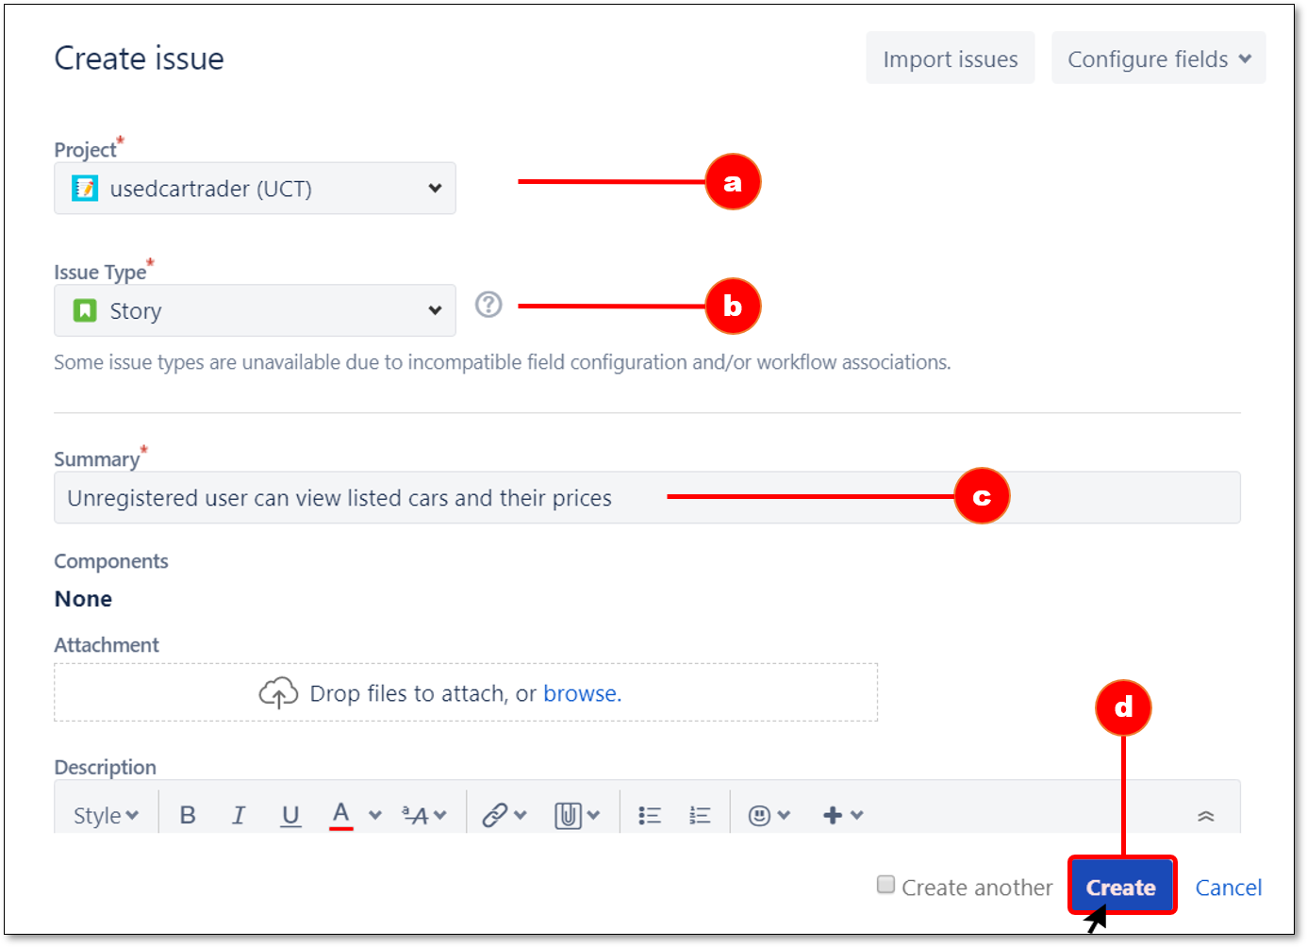

Once you create the issue, you will see it in the backlog. You can then assign it to the epic or version and add it to the sprints.

**💡Tips:**

* If you are creating multiple issues, select the **Create another** checkbox in the dialog to keep the it open.
* You can quickly create issues by clicking **+ Create issue** in the Backlog.
* The issue is given a unique key associating it with the project

### Creating Epic

An epic is a set of jobs that can be divided into manageable and shippable user stories based on the needs of customers. Epic is the best way to group similar user stories. It may take several sprints to complete an epic.

There are two ways of creating an epic:

* Creating an epic from a new issue ([How to Create an Issue](https://lms.clarusway.com/mod/lesson/view.php?id=1433&pageid=2982))
* Creating an epic from the Epics panel

**💡Tips:**

* Epics do not show up as cards in sprints or in the backlog.

Follow the next steps to create a new epic from the Epics panel.

**Q**: What is an epic in Jira Software?  
**A**: An epic is a set of jobs that can be divided into manageable and shippable user stories based on the needs of customers. Epic is the best way to group similar user stories. It may take several sprints to complete an epic.

Step-1 (Click on "EPICS")

Click on "EPICS" from the left-hand panel on the backlog screen.

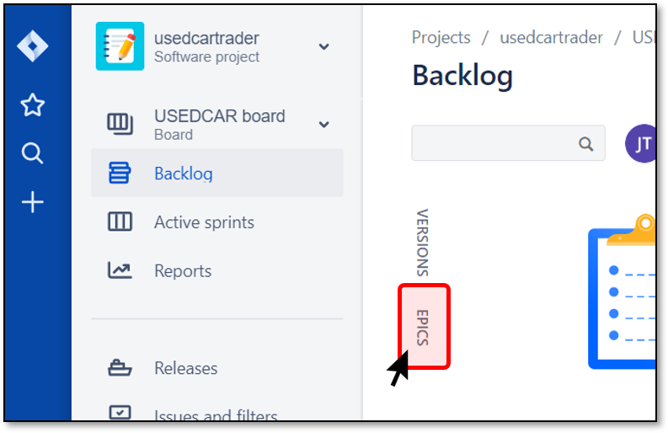

### Step-2 (Click on "Create Epic")

Click on the "Create Epic" link in the expanded Epics panel. This will direct you to the "Create epic" dialogue box.

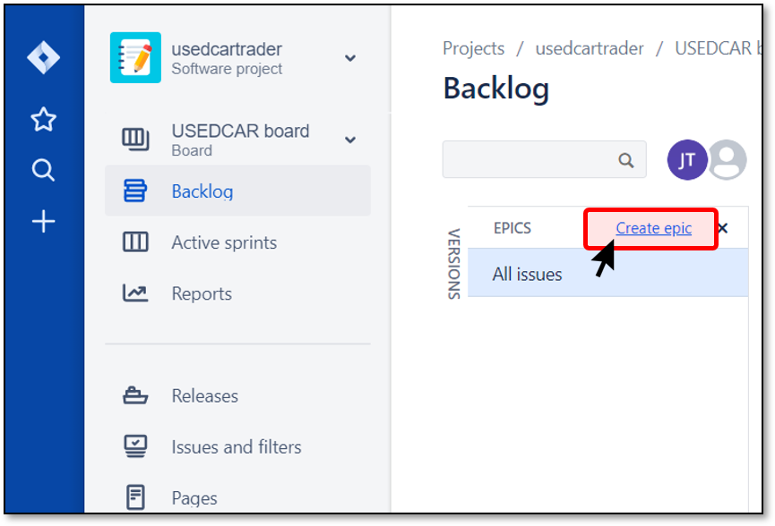

### Step-3 (Dialogue Box)

Fill in the fields in the dialogue box as shown in the following picture.

a. Select the Project,

b. Select the Issue Type as "Epic",

c. Provide a name for the epic,

d. Provide a Summary,

e. Fill in the additional fields and click on the Create button.

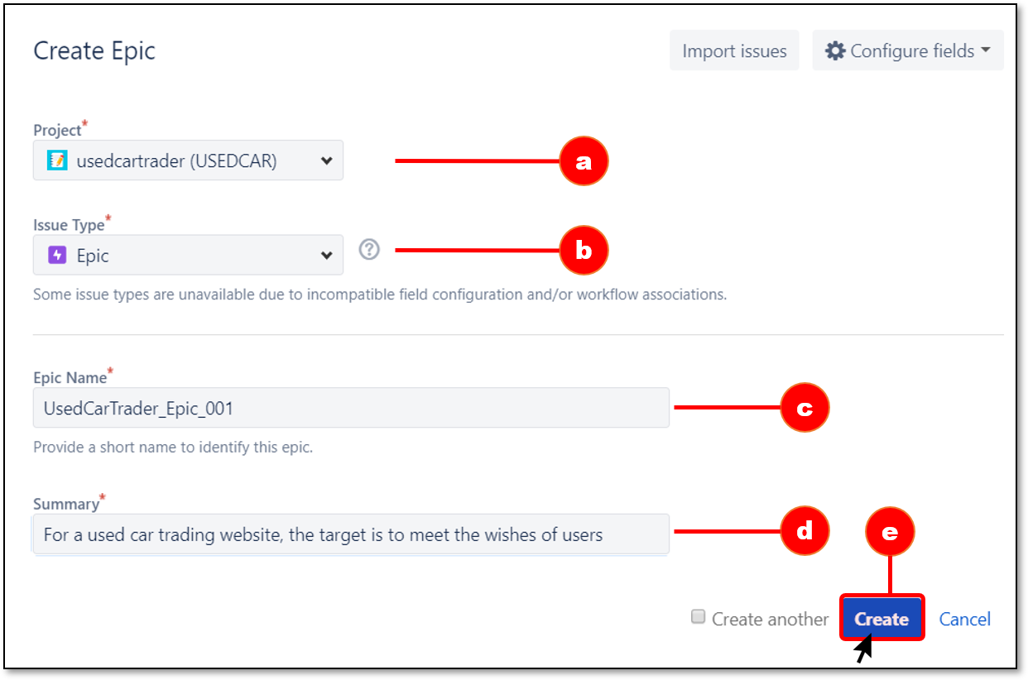

### Creating Subtask

A subtask can be created to divide an issue into smaller pieces and allow them to be assigned to different people.

Here are some important things to know when creating a subtask:

* You can have as many subtasks as you want under a parent issue.
* You cannot create a subtask under a subtask.
* If you add a subtask under a parent issue, the parent issue cannot be converted to a subtask.

In Jira Sofware, a subtask can be created in two ways:

* Creating an issue into a sub-task ([How to Create an Issue](https://lms.clarusway.com/mod/lesson/view.php?id=1433&pageid=2982))
* Creating a sub-task under a parent issue

Follow the next steps to create a subtask under a parent issue.

**💡Tips:**

* If you find that a subtask is large enough at an issue level, you can convert it into an issue.
* Likewise, if you see that an issue is really just a subtask of another issue, you can convert it into a subtask.

### Step-1 (Click on Parent Issue)

Click on an issue where you want subtasks to be created. The issue you selected will be the parent issue of the subtask.

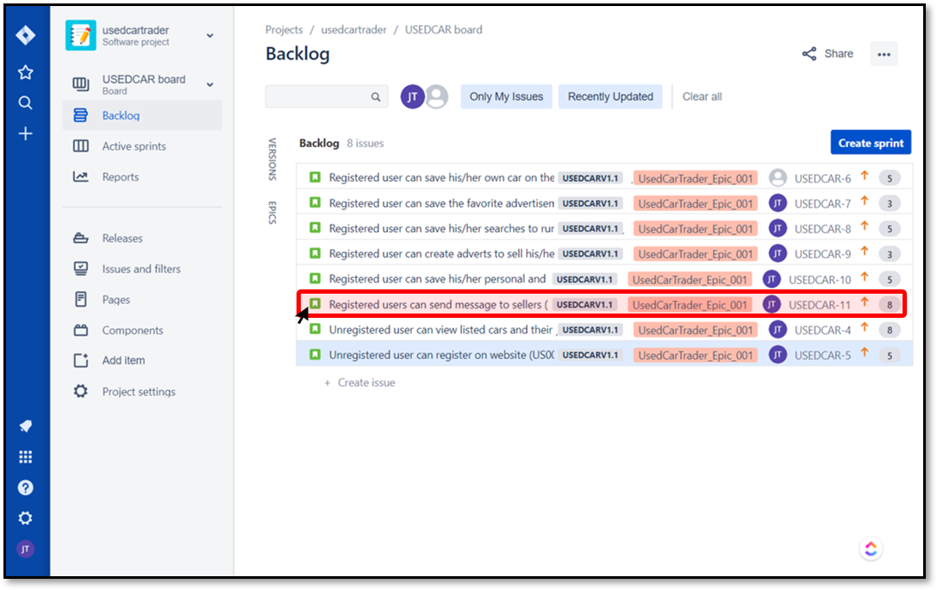

### Step-2 (Click "Create subtask")

From the dialog box, click Create subtask.

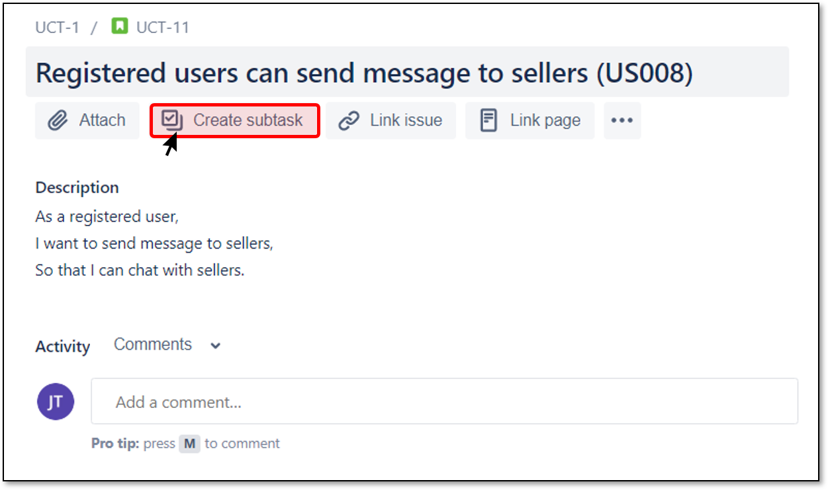

### Step-3 (Add Summary)

Add a summary to your subtask and click "Create" button.

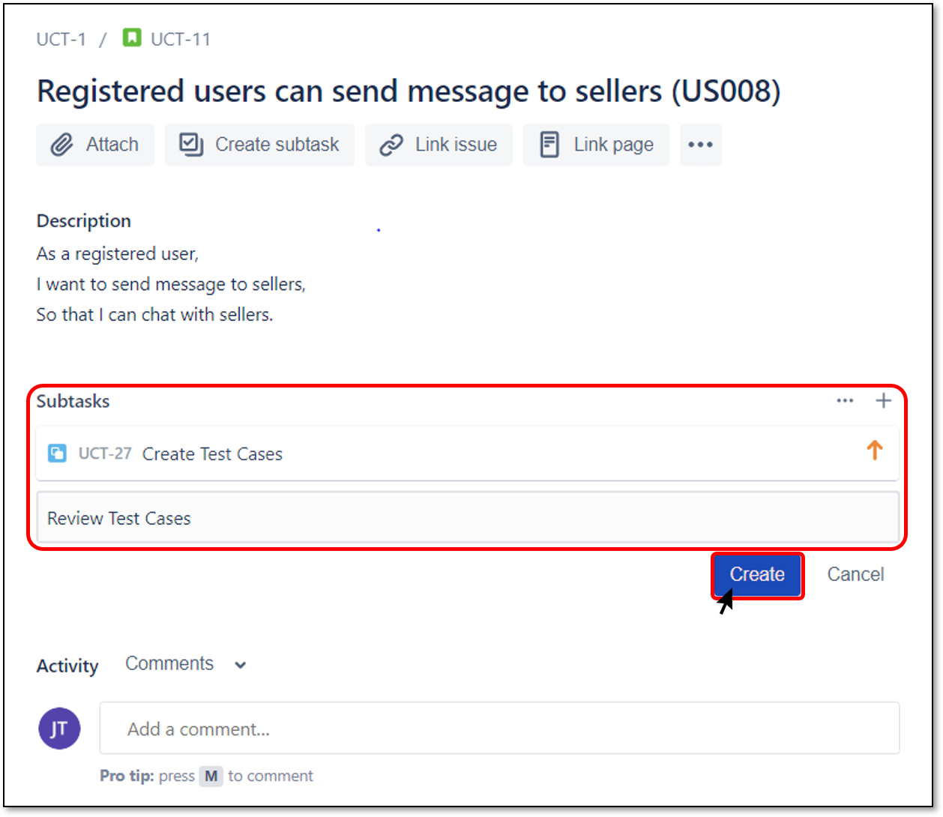

### Step-4 (Subtask Fields)

Click on a subtask that you have created and you can do the followings:

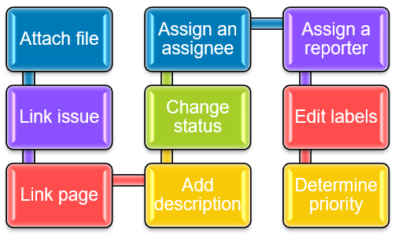

The following screenshot shows subtask fields:

|  |
| --- |
| Subtask Fields |

**Q**: Explain how a subtask is created in Jira Software.  
**A**: Follow these steps to create a subtask. Click on an issue where you want subtasks to be created. From the dialog box, click on the "Create subtask" button. Add a summary to your subtask and click on "Create" button. Click on a subtask that you have created and you can do the followings: Attach file, Link issue, Link page, Change status, Assign an assignee, Assign an reporter, Edit labels, Determine priority.

Which of the following statements is/are TRUE?

Select one or more:



You can have as many subtasks as you want under a parent issue.

Correct!



If you add a subtask under a parent issue, the parent issue cannot be converted to a subtask.

Correct!



You can create a subtask under a subtask.

### Creating Bug

After capturing bugs in your projects, you can create an issue and add all the details about it. Follow these steps to create a bug from your Scrum board:

### Step-1 (Click on "+")

Click "+" button from global navigation bar or press the C key on the keyboard. This will direct you to "Create issue" dialogue box.



### Step-2 (Dialogue Box)

Fill in the fields in the dialogue box.

a. Select the Project,

b. Select the Issue Type as "Bug",

c. Provide a Summary,

d. Provide a Description,

e. Determine Priority,

f. Edit Affect Versions,

g. Set an Assignee,

h. Fill in the additional fields and click on the "Create" button.

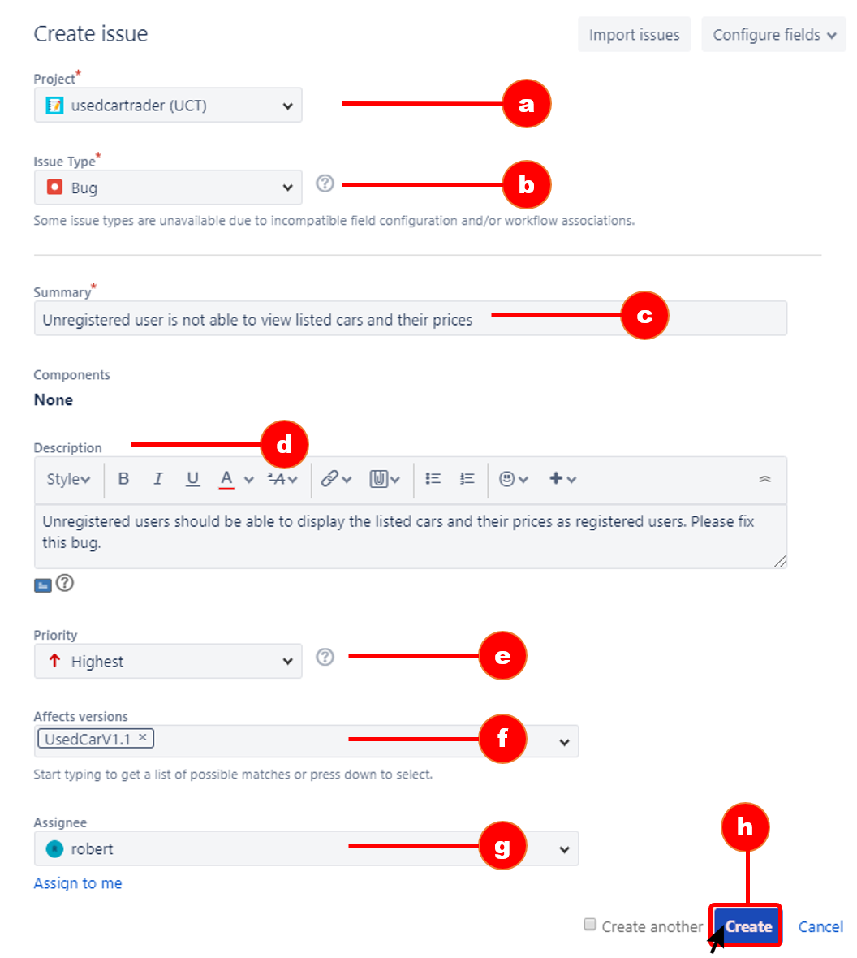

Logging Time on Issues

Your team needs to track the time they spend from sprint to sprint to know how much work they can fit in each future sprint.

Here are the steps how to log time on an issue:

1. Open the issue you are working and select ••• > **Log work** (or click on the **time tracking** field)

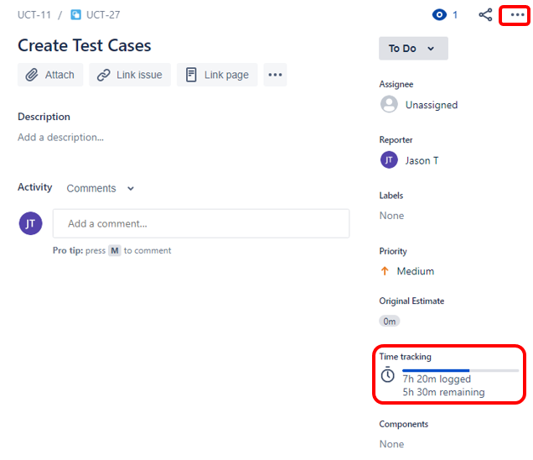

1. Fill in the **Log time** fields and select **Save**

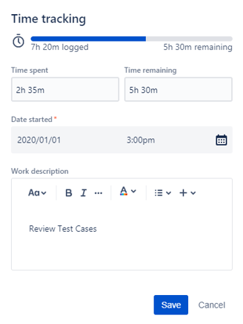

When logging time, use the format: 2w 4d 5h 45m.

**💡Tips:**

* Time tracking is enabled by default in Jira; if you disable or re-enable, you will not lose any existing data.

### Cloning an Issue

Cloning an issue (copying an issue) allows you to quickly create a copy of an issue within the same project. The clone issue has the same information stored in the original issue.

When cloning an issue, it is necessary to know the following points:

* A clone issue and original issue are separate entities.
* Operations in the original issue do not affect the information related to the clone issue. Likewise, operations in the clone issue do not affect the information related to the original issue.
* The only connection that relates the clone to the original issue can be a link if one exists.

A clone issue copies the following fields from the original issue:

|  |  |  |
| --- | --- | --- |
| Summary | Description | Assignee |
| Environment | Priority | Issue Type |
| Security | Reporter | Components |
| Affects Versions | Fix For Versions | Issue Links (optional) |
| Attachments (optional) | Project |  |

The fields that aren't copied:

|  |  |
| --- | --- |
| Time tracking | Comments |
| Issue history | Links to Confluence pages |

Here are the steps how to clone an issue:

1. Open the original issue you want to clone and select ••• > **Clone**.

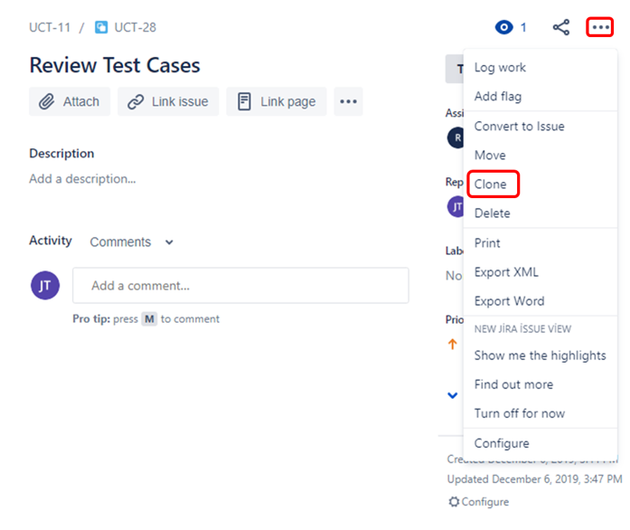

1. Fill in the **Summary** field and click **Create**.

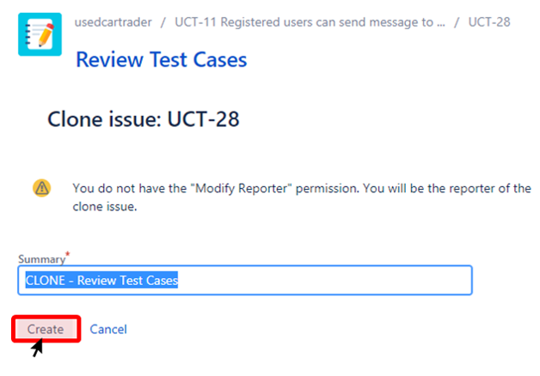

### Starting Sprint

A sprint is a short period (ideally two to four weeks) during which a development team implements and delivers a discrete product increment, e.g. a working milestone version.

So far we have created an account in Jira Software. We have created a new scrum project and learned how to create version, epic, story, subtask and bug. Now it's time to start preparing the sprint.

Let's remember briefly the meaning of sprint. **A sprint** is a container for all of the work a team decides to do for a specific time period. Once you have plenty of issues in your backlog, you can start a sprint.

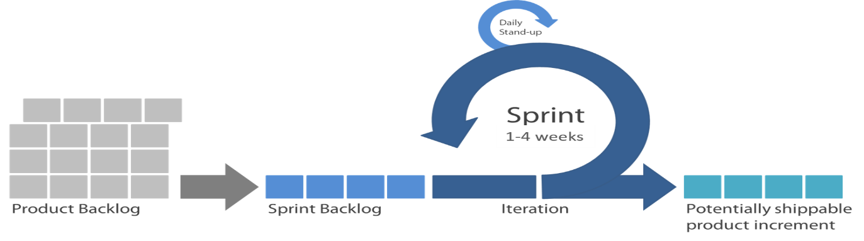

**💡Tips:**

* You can plan multiple sprints at one time.
* You won't be able to start a new sprint until the active sprint is completed unless your Jira administrator has configured parallel sprints.

### Step-1 (Click on "Create Sprint")

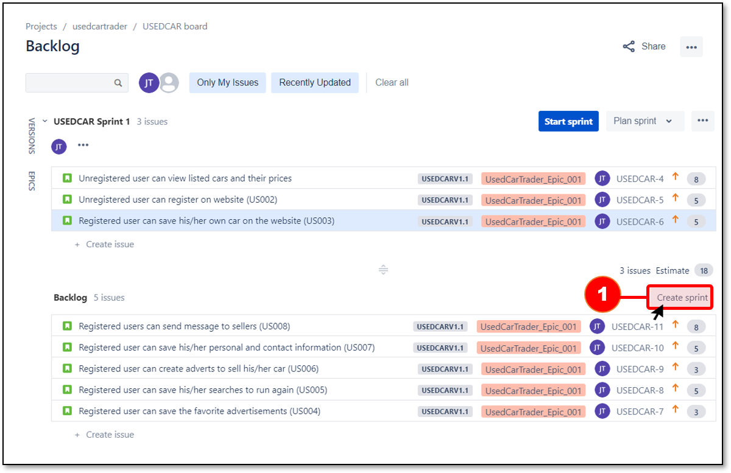Create a sprint by clicking on the "Create Sprint" button from the backlog

### Step-2 (Fill in the Sprint Backlog)

Add issues from the product backlog into the sprint backlog by dragging and dropping.

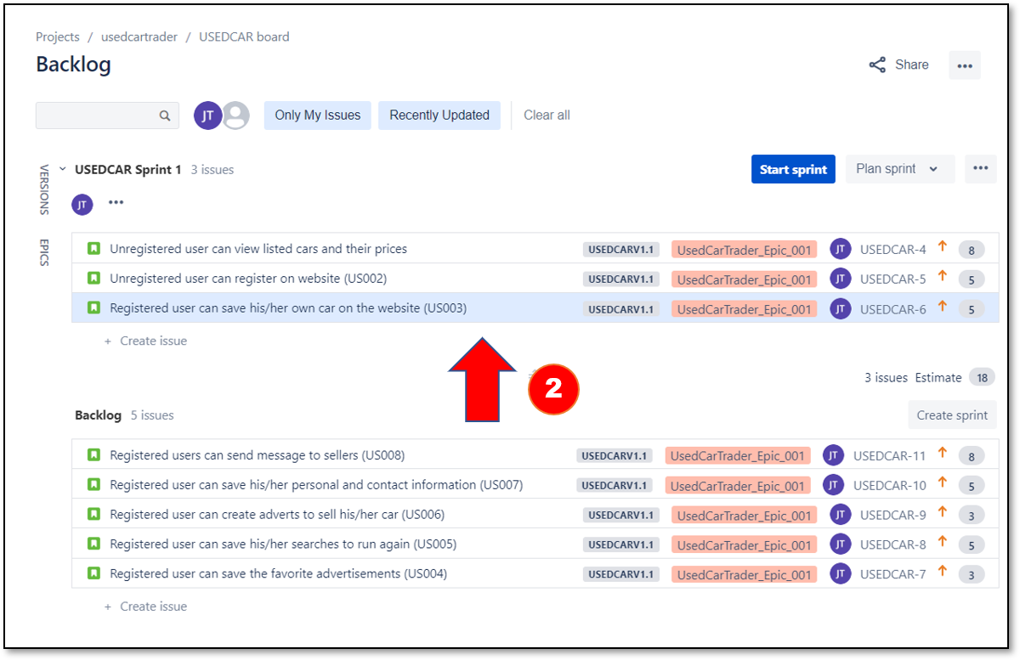

### Step-3 (Click on "Start Sprint")

After you add all the issues you plan in the sprint, click on the "Start Sprint" button.

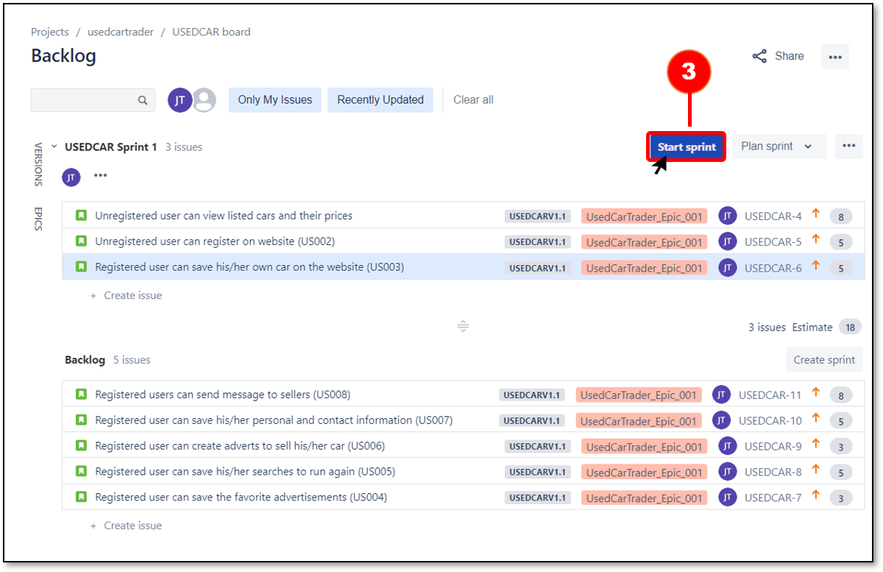

**💡Tips:**

* Note that starting a sprint requires the appropriate permission. If you are unable to start a sprint, reach out to your Jira Administrator.

### Step-4 (Dialogue Box)

Fill in the fields in the dialogue box as shown in the following picture.

a. Provide a name for the sprint,

b. Set the duration of the sprint,

c. Set the start date,

d. See the end date automatically updated,

e. Provide the sprint goal,

f. Click on the Start button.

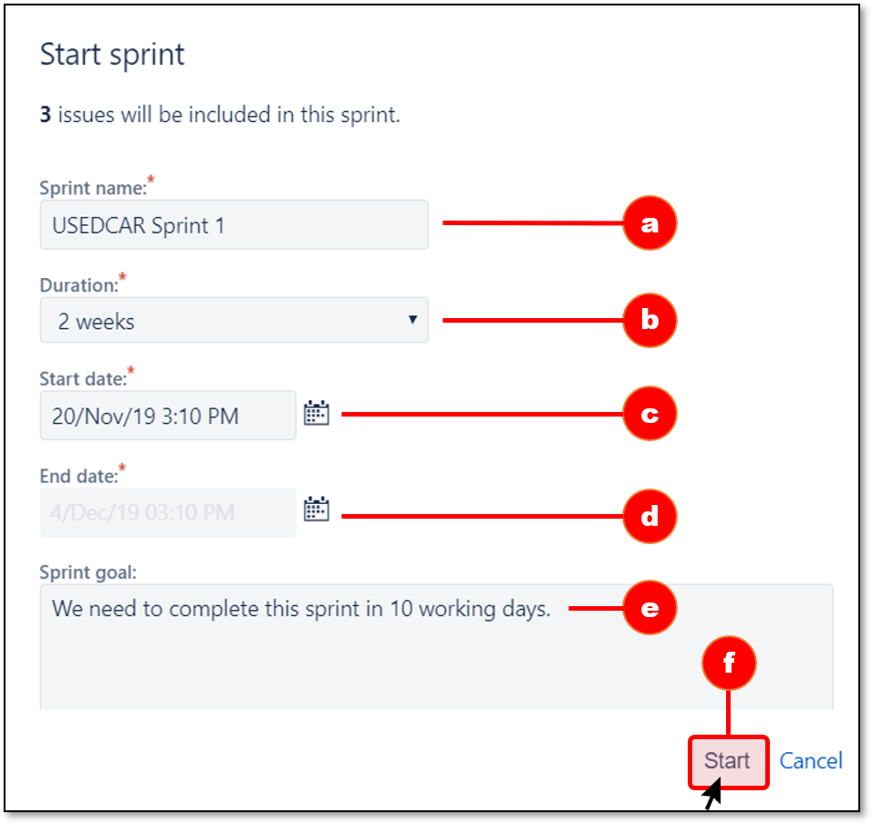

**💡Tips:**

* When applying agile, it is best to keep your sprints 1-4 weeks long.

### Working with Sprint

After you start a sprint:

* The issues in your sprint move onto your board.
* The board name changes to the name of your active sprint.
* The sprint goal appears on the board.
* The amount of time remaining in the sprint appears on the board.

Once you start a sprint, you will then enter the active sprint mode. All issues that are part of the sprint will be displayed. Active sprints of a Scrum board exhibit the issues your team is working on.

In the active sprint mode, you will notice that the board is divided into three columns:

* To Do: The issue is waiting to start
* In Progress: The issue is currently being worked on
* Done: The issue has been completed

You can drag and drop issue cards between these columns to change their statuses. By doing this, you can convert issues into a workflow for your team. Besides, you can see how many days are left on the active sprint screen for the end of the sprint.

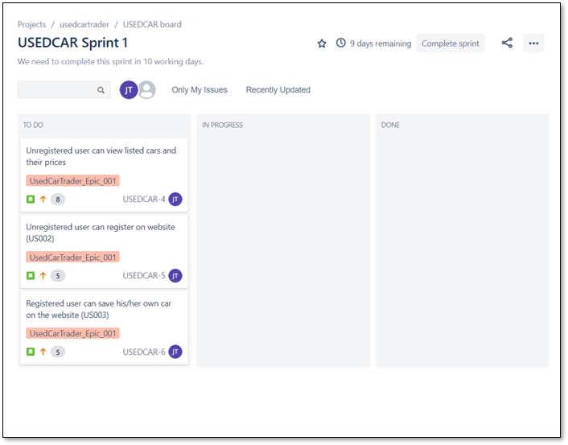

### Completing Sprint

When the sprint is closed, any issues that aren't in the Done column will show as incomplete on the reports. Before completing your sprint, review the board one last time to ensure that all issues are in the right column.

When the sprint is finished, you can complete the sprint by following the steps below:

### Step-1 (Click on "Complete Sprint")

Select "Active Sprint" from your board and click on the "Complete Sprint" button.

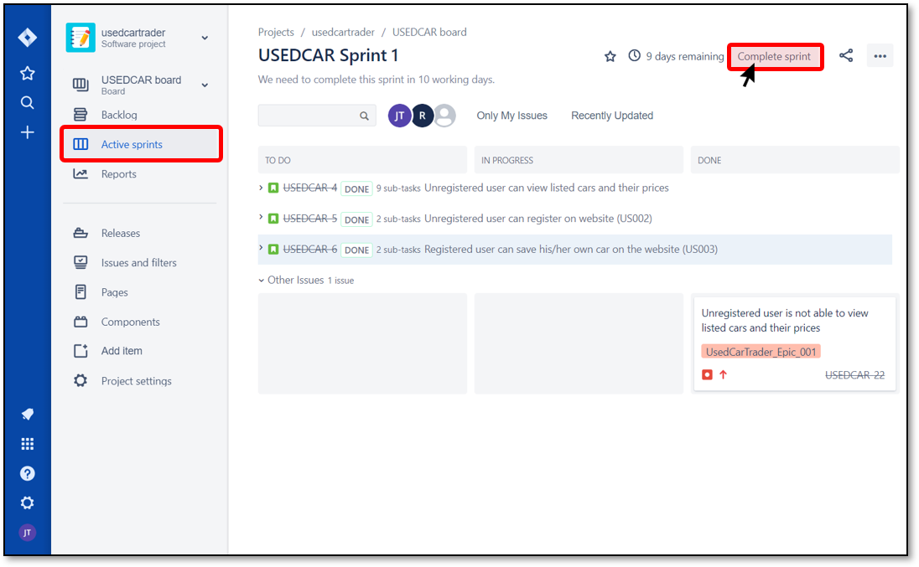

### Step-2 (Click on "Complete")

It will then open the "Complete Sprint" dialog box, which summarizes Sprint's current status. This dialog box tells you how many issues have been completed in this sprint and any incomplete issues will be moved to your backlog.

Click on the "Complete" button to complete the sprint.

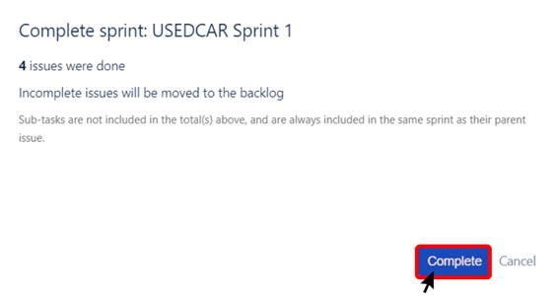

Reports in Jira

**To do: Go through the activity to the end**

### Reporting a Sprint's Progress

Keeping track of progress while working on a project is important for achieving your plans and goals. Jira makes it easy for you by producing several useful reports through Report mode. While your team is working on the sprint, you can browse Report mode at any time. These reports will also be useful during sprint retrospective meetings because they provide detailed information on how sprint is progressing.

Find reports in the Reports area of your project. In the sidebar you see all the available reports and you simply click one to run it.

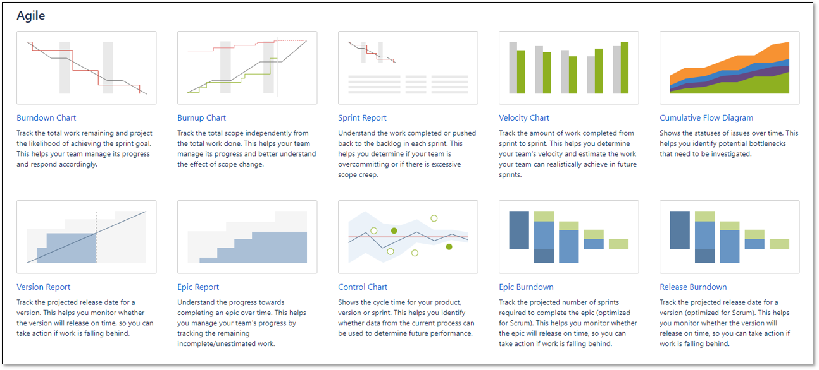

We will now cover three of the agile reports. The reports we will cover are as follows:

* Burndown Chart
* Sprint Report
* Velocity Chart

**Q**: What are the agile reports in Jira Software?  
**A**: The reports generated by any Scrum project in JIRA are: Burndown Chart, Burnup Chart, Sprint Report, Velocity Chart, Cumulative Flow Diagram, Version Report, Epic Report, Control Chart, Epic Burndown, and Release Burndown.

### Burndown Chart

A Burndown chart is a graphical representation of the work left to be done (STORY POINTS) versus the time remained in the active sprint (TIME). It illustrates work completed and work remaining to be done. The Burndown Chart gives everyone involved a clear sense of the progress of the project.

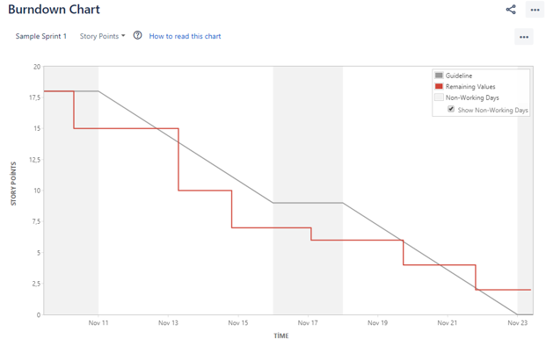

The Sprint report displays a condensed burndown chart and lists which issues are complete and which are still incomplete.

The Sprint report also shows items that were added to the sprint late, thus changing the sprint's scope. These reports are useful for mid-sprint check-ins as well as retrospective meetings.

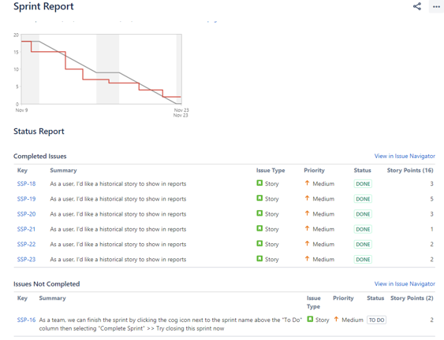

Velocity Chart

The Velocity Chart shows the amount of value delivered in each sprint, enabling you to predict the amount of work the team can get done in future sprints. It is useful during your sprint planning meetings, to help you decide how much work you can feasibly commit to.

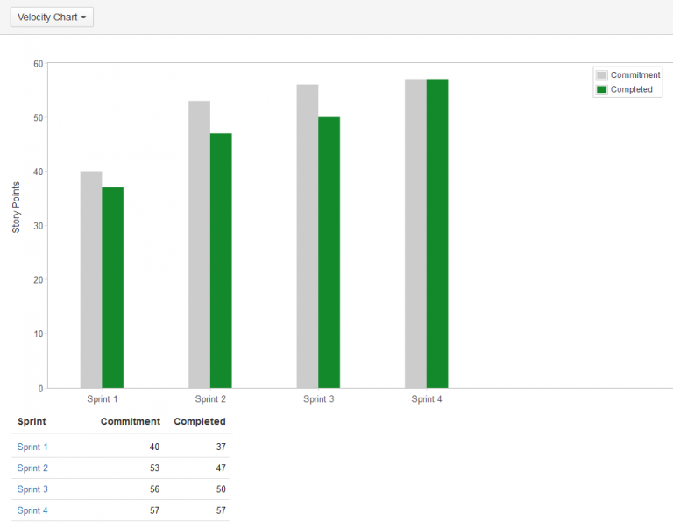

The y-axis displays the statistic used for estimating stories. In the example above, the team is using story points. The x-axis displays the sprints completed by the team. The gray bar for each sprint shows the total estimate of all issues in the sprint when it begins. The green bar in each sprint shows the total completed estimates when the sprint ends.

## What is Jira?

Jira is a tool developed to help teams for project management, bug tracking, and issue tracking. In simple terms, it is an **issue tracker**. Jira is widely used by big companies in software development and software testing. It is web-based and licensed product created by Australian Company [Atlassian](https://www.atlassian.com/).

## List the Atlassian products that are members of Jira family.

Jira is divided into four different products and the term Jira is referred to as a common platform in which all these products are created. The four products of the Jira family are:

* Jira Software
* Jira Align
* Jira Core
* Jira Service Desk

## Which hosting options are available for Jira Software?

Teams can use Jira Software with two hosting options: cloud and self-managed. Customers using the self-managing option can choose between server and data center.

Cloud: With Jira Software Cloud, the Jira Software site is hosted and installed in the cloud for you. This hosting option is usually preferred by the teams who want to get started quickly and practically.

Server: Jira Software Server allows you to host Jira Software on your own hardware and customize it to suit your needs when installing. This is often the best option for teams that have experience with self-hosted applications and need to manage all the details.

Data Center: With this option, Jira Software can be hosted on your hardware or public cloud services such as Amazon Web Services (AWS) and Microsoft Azure. Jira Software Data Center is often the best deployment option for enterprise teams that need uninterrupted access and high performance.

## What is an issue in JIRA Software?

In Jira, teams use issues to track individual pieces of work that must be completed. During the sprint planning, users can create issues that they plan to work on and add them to the backlog.

## What is referred as issues in Jira?

Depending on how a team uses Jira, an issue can represent followings:

* Project task
* Feature
* Help-desk ticket
* Leave request form
* Enhancement
* Software bug

## List and briefly describe the issues types in Jira Software?

Issue types can be defined in short sentences as follows:

* **Task**: A task represents the job that needs to be done.
* **Story**: A story is a short requirement written from an end-user perspective.
* **Epic**: An epic is a set of jobs that can be divided into manageable user stories.
* **Bug**: A bug impairs expected functionality of the product.
* **Subtask**: A subtask can be considered as a smaller piece of a story.

## Explain how an issue is created in Jira Software.

Follow these steps to create an issue:

1. Click on "+" button from the global navigation bar or press the C key on the keyboard. This will direct you to the "Create issue" dialogue box.
2. Select the relevant Project and Issue Type in the Create Issue dialog box.
3. Provide a Summary in the Create Issue dialog box.
4. Fill in the additional fields in the Create Issue dialog box.
5. Click on the “Create” button.

## What is a subtask in Jira Software?

A subtask can be created to divide an issue into smaller pieces and allow them to be assigned to different people. If you find that a subtask is large enough at an issue level, you can convert it into an issue. Likewise, if you see that an issue is really just a subtask of another issue, you can convert it into a subtask.

## Explain how a subtask is created in Jira Software.

Follow these steps to create a subtask:

1. Click on an issue where you want subtasks to be created.
2. From the dialog box, click on the "Create subtask" button.
3. Add a summary to your subtask and click on "Create" button.
4. Click on a subtask that you have created and you can do the followings:

* Attach file
* Link issue
* Link page
* Change status
* Assign an assignee
* Assign an reporter
* Edit labels
* Determine priority

## What is project key in Jira Software?

A project key is a unique code for your project. Jira Software will automatically generate a short project key in accordance with your project name. However, if you want to specify this auto-generated key yourself, you can change it.

## Is it possible to access JIRA cloud site via a mobile device?

You can access your Jira Software site from mobile devices by typing the address of your site into web browsers.

## What are the agile reports in Jira Software Cloud?

The reports generated by any Scrum project in JIRA are

* Burndown Chart
* Burnup Chart
* Sprint Report
* Velocity Chart
* Cumulative Flow Diagram
* Version Report
* Epic Report
* Control Chart
* Epic Burndown
* Release Burndown

## How many sidebars are available in Jira Software and what are they? What does sidebar colors mean?

The sidebar consists of two parts:

* A global sidebar where you can search, create issues, and manage your profile settings. [Learn more](https://confluence.atlassian.com/jiracorecloud/get-home-search-or-create-with-the-global-sidebar-937885946.html).
* Either an application sidebar or a project sidebar, depending on your context.

The sidebar shows different navigation and menu items, depending on where you are in Jira.

The sidebar colors help keep you oriented when navigating: Blue means you're at the product level. Gray means you're at the project level.

## Explain briefly what is backlog.

A backlog is a list of issues that can be created for your project. You can create issues and sprints in the backlog. Then, you can add issues to a sprint so that your team can work on it. These issues are not detailed features in your backlog.

## Explain briefly what is version.

In Jira Software, the versions represent the points of a project over time. With versioning, you can plan the order in which new features and fixes for the product will be released to your customers.

## What is an epic in Jira Software?

An epic is a set of jobs that can be divided into manageable and shippable user stories based on the needs of customers. Epic is the best way to group similar user stories. It may take several sprints to complete an epic.

## What is Jira Workflow?

A Jira workflow is a set of statuses and transitions that an issue moves through during its lifecycle, and typically represents a process within your organization. Workflows can be associated with particular projects and, optionally, specific issue types by using a workflow scheme.

#### **Backlog**

#### A backlog is a list of the outstanding user stories, bugs and features for a product or sprint. **Board**

The tool that teams use to visualize units of work moving through their specific workflow. It can be adapted for different styles of agile development (e.g. a Scrum board shows work items moving from the product backlog to the sprint backlog whereas a Kanban board typically has a three-step workflow: To Do, In Progress, and Done).

#### **bug**

A bug impairs expected functionality of the product

#### **Burndown Chart**

A Burndown Chart shows the actual and estimated amount of work to be done in a sprint.

#### **Control Chart**

A Control Chart can show the cycle time or lead time for your product, version or sprint.

#### **Cycle Time**

Cycle time is the time spent working on an issue – typically, the time taken from when work begins on an issue to when work is completed, but also includes any other time spent working on the issue. For example, if an issue is reopened, worked on, and completed again, then the time for this extra work is added to the cycle time.

#### **Daily stand-up**

Also known as a daily scrum, a 15-minute mini-meeting for the software team to sync.

#### **Epic**

An epic captures a large body of work that needs to be broken down into a number of smaller stories. It may take several sprints to complete an epic. The hierarchy for units of work in Jira Software is as follows: Project > Epics/Components > Stories > Tasks > Subtasks

#### **Filter**

Filters determine what is visible on each of your boards. Using Jira's simple query builder (JQL), you can customize exactly which issues are displayed on your board.

#### **Issue**

An issue is simply a unit of work within Jira that will be traced through a workflow, from creation to completion. It can range from representing a single unit of work, like a simple task or bug, to a larger parent work item to be tracked, like a story or an epic.

#### **Kanban**

Kanban is a system for visualizing the flow of work and limiting work in progress. Kanban is not oriented towards sprints, like Scrum development methodology, as it is more ongoing

#### **Scrum**

Scrum is an Agile development methodology where the product is built in a series of fixed-length iterations called sprints. It gives teams a framework for shipping software on a regular cadence.

#### **Scrum of Scrums**

Scrum of Scrums is a means of scaling Scrum to large, multi-team projects. Scrum of Scrums is the Agile version of what is traditionally known as program management.

#### **Sprint**

A sprint — also known as an iteration — is a short (ideally two to four week) period in which the development team implements and delivers a discrete product increment, e.g. a working milestone version.

#### **Sprint planning**

A team planning meeting that determines what to complete in the coming sprint.

#### **Sprint retrospective**

A review of what did and didn't go well with actions to make the next sprint better.

#### **Story**

A story or user story is a software system requirement that is expressed in a few short sentences, ideally using non-technical language.

#### **Story Point**

A story point is an estimate of the relative complexity of a story.

#### **Sub-Task**

A sub-task can be a "child" of any issue type, depending on the Issue Type Scheme of the project.

#### **Swimlane**

A swimlane is a means of categorizing issues so that agile teams can see which issues they should work on next.

#### **Task**

A task is another out-of-the-box issue type in Jira.

#### **Velocity**

The velocity of a team is a measure of how much work that the team can handle within a specific time period, i.e. how much of the product backlog can be completed by the team in a sprint. Velocity can be calculated on the basis of story points, business value, hours, issue count, or any numeric field of your choice.

#### **Workflow**

Workflow is the logic that drives movement of a stories / sub-task along their development journey on a scrum or kanban board.